|  |  |
| --- | --- |
| Masterton Primary School | Facebook | **Charter/Strategic plan 2023 -2025**  Gene Bartlett |

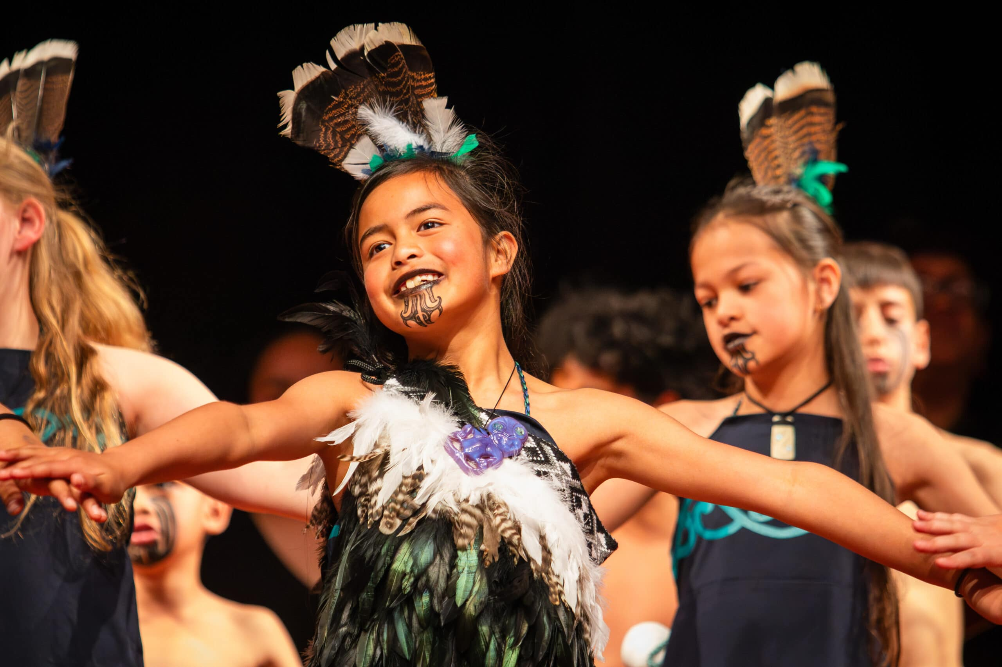**Our School**

**Masterton Primary School** is a vibrant and dynamic educational hub located in the heart of our community. Our school is committed to fostering a nurturing and inclusive environment where every child can thrive academically, socially, and emotionally. We are dedicated to providing a high-quality education that is accessible and responsive to the diverse needs of our students and their families.

**Our Purpose**

At Masterton Primary School, our purpose is to create an enriching educational environment that empowers every child to reach their full potential. We are dedicated to:

1. **Academic Excellence**: Providing a high-quality education that challenges and supports students in achieving their academic goals.
2. **Holistic Development**: Fostering the social, emotional, and physical development of our students, ensuring they grow into well-rounded individuals.
3. **Inclusivity and Diversity**: Celebrating the diverse backgrounds and abilities of our students, promoting an inclusive atmosphere where every child feels valued and respected.
4. **Cultural Responsiveness**: Embracing and integrating the cultural traditions and languages of our student body, with a special focus on honouring Māori culture through our commitment to the principles of Te Arawhakamana.
5. **Community Engagement**: Building strong partnerships with families and the wider community to support the educational journey and well-being of our students.
6. **Lifelong Learning**: Inspiring a love for learning and curiosity that extends beyond the classroom, preparing students for future success in a rapidly changing world.
7. **Student-Centred Approach**: Placing the child at the heart of everything we do, ensuring that every decision, program, and classroom environment is designed with the best interests of our students in mind.

Our mission is to nurture the growth, well-being, and happiness of every student, providing them with the skills, knowledge, and values they need to thrive in life.

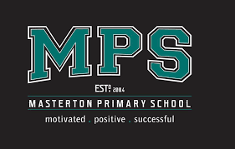

## **Mission Statement**

We aim to encourage our students to be,

#### **Motivated**

#### **Positive, and**

#### **Successful**

At Masterton Primary School, our mission is clear: to provide an environment where every child can thrive academically, socially, and emotionally. Our commitment to inclusivity is at the very heart of who we are as a school. We celebrate the rich diversity of our students and their families, ensuring that every child, regardless of their background or abilities, feels valued, welcomed, and supported. Inclusivity is not just a word here; it’s a fundamental part of our identity.

## **Culturally responsive**

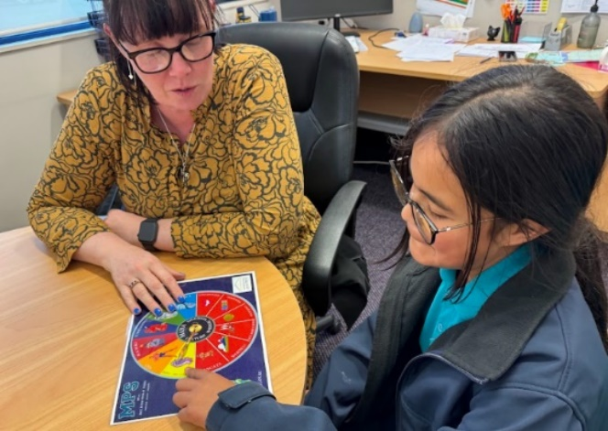We are a culturally responsive school, embracing the traditions, languages, and heritage of our diverse student body. By acknowledging and respecting the cultural backgrounds of our students, we create an atmosphere where every child can truly flourish. Values such as Manaakitanga and Rangatiratanga guide us in our daily interactions, reminding us to nurture the well-being and potential of every individual.

#### Understanding Te Arawhakamana

Te Arawhakamana, which can be translated as “The Pathway of Empowerment,” is a holistic approach rooted in Māori values, language, and customs. It aims to provide students with a sense of identity and belonging, encouraging them to take pride in their cultural heritage. The framework is grounded in several key principles:

1. 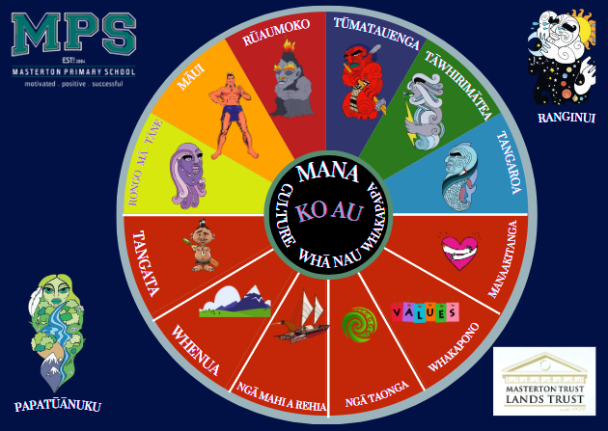**Whanaungatanga (Relationships)**: Building strong, supportive relationships within the school community.
2. **Manaakitanga (Caring)**: Showing care and respect for others.
3. **Kotahitanga (Unity)**: Promoting unity and collaboration among students and staff.
4. **Rangatiratanga (Leadership)**: Encouraging leadership and self-determination.

#### Implementation at Masterton Primary School

Masterton Primary School is integrating Arawhakamana into its curriculum and school culture. This integration is evident in various aspects of school life:

1. **Curriculum Integration**: Māori language (Te Reo Māori) and cultural studies are incorporated into the regular curriculum, allowing all students to learn and appreciate Māori traditions. This includes learning waiata (songs), haka (traditional dances), and engaging in storytelling that reflects Māori heritage.
2. **Cultural Events and Celebrations**: The school regularly hosts events such as Matariki (Māori New Year) celebrations, pōwhiri (welcoming ceremonies), and cultural days where students participate in activities that highlight Māori customs and practices.
3. **Student Leadership**: The school encourages students to take on leadership roles through initiatives such as the Mana Council, where students can voice their opinions and contribute to decision-making processes that affect their learning environment.
4. **Professional Development for Staff**: Teachers and staff undergo regular training to deepen their understanding of Te Arawhakamana principles and how to effectively integrate them into their teaching practices. This ensures that the school’s commitment to cultural empowerment is reflected in every classroom.
5. **Community Involvement**: Masterton Primary School actively involves parents and the local community in its initiatives, fostering a sense of unity and shared responsibility for the education and cultural growth of the students.

#### Impact and Outcomes

The adoption of Te Arawhakamana at Masterton Primary School has yielded significant positive outcomes. Students report a stronger sense of identity and pride in their cultural heritage. The inclusive environment has also led to improved student engagement and academic performance. Additionally, the school has seen a strengthened sense of community as students, parents, and staff work together towards common goals.

By embracing Te Arawhakamana, we are not only preserving and promoting Māori culture but also setting a powerful example of how education can be a transformative force in fostering cultural understanding and empowerment. As the school continues to develop and refine its approach, it stands as a beacon of cultural inclusivity and educational excellence in New Zealand.

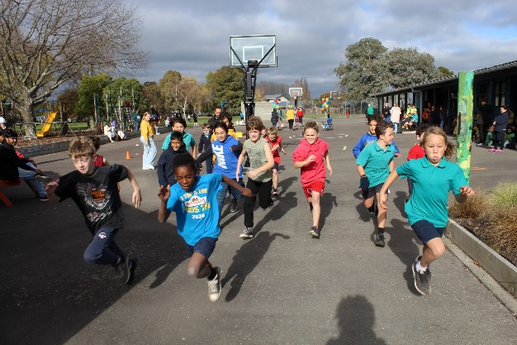**Embracing Diversity at Masterton Primary School**

At Masterton Primary School, diversity is not just accepted; it is celebrated every day. As soon as students walk through the gates each morning, they are greeted with open arms. The school prides itself on fostering connections not only among students but also with their families and the wider community.

Masterton Primary School is home to a rich and diverse student body. Students come from a variety of backgrounds, including India, Pakistan, Samoa, New Zealand Maori, European, Middle Eastern, Tonga, Southeast Asia, Fiji, and Africa. This melting pot of cultures, languages, and traditions makes the school a vibrant and inclusive place to learn and grow.

To further support this diversity, Masterton Primary School has employed a bilingual support worker who is able to break down language barriers. She speaks Urdu, Hindi, Punjabi, and English, ensuring that communication is smooth and effective for students and families from these linguistic backgrounds.

Through embracing diversity, Masterton Primary School teaches its students the value of respect, empathy, and understanding. Students learn to appreciate different perspectives and celebrate what makes each individual unique. By learning alongside peers from diverse backgrounds, students gain a broader worldview and develop important social skills that will serve them well beyond the school years.

The school actively promotes cultural exchanges and events that showcase the traditions and heritage of its diverse student body. This not only enriches the educational experience but also fosters a sense of unity and belonging among all students, regardless of where they come from.

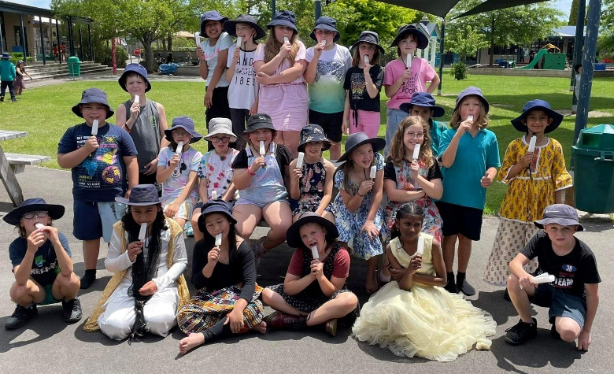At Masterton Primary School, diversity is not just a concept; it is a way of life. Students learn to see the beauty in differences and to build connections that transcend cultural boundaries. By embracing diversity, Masterton Primary School creates a nurturing environment where every student feels valued, respected, and empowered to succeed.

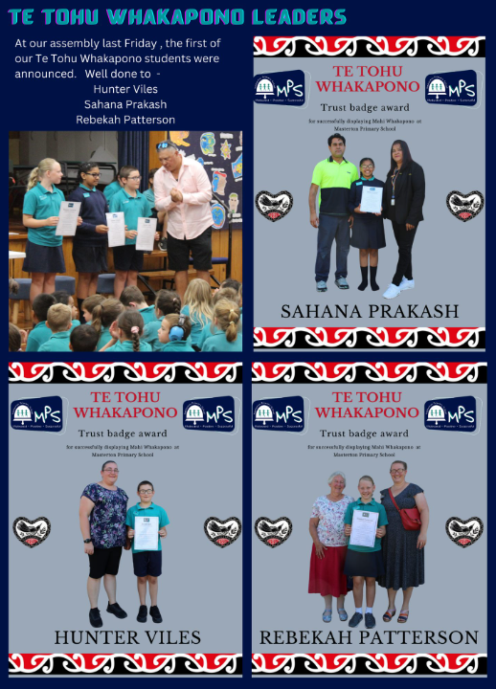**Celebrating success**

### Te Tohu Whakapono Leaders at Masterton Primary School

At Masterton Primary School, Te Tohu Whakapono Leaders are selected as senior role models for the student community. These leaders consistently demonstrate the following qualities:

* Reliability
* Responsibility
* Trustworthiness in all contexts
* Respect for others
* Courtesy towards peers and adults
* Independence
* An ability to moderate behaviour in a range of situations
* An ability to be a positive role model for younger students
* A willingness to help others

#### Privileges

Due to their trustworthiness and exemplary behaviour, Te Tohu Whakapono Leaders are granted the following privileges:

* Unsupervised use of the Hall and Library during break times
* An invitation to a Staff Room morning tea shout in their honour
* An invitation to an end-of-year fun day out

#### A collage of people holding a flag Description automatically generatedResponsibilities

Te Tohu Whakapono Leaders also take on important responsibilities:

* Wearing the Te Tohu Whakapono Badge at all times
* 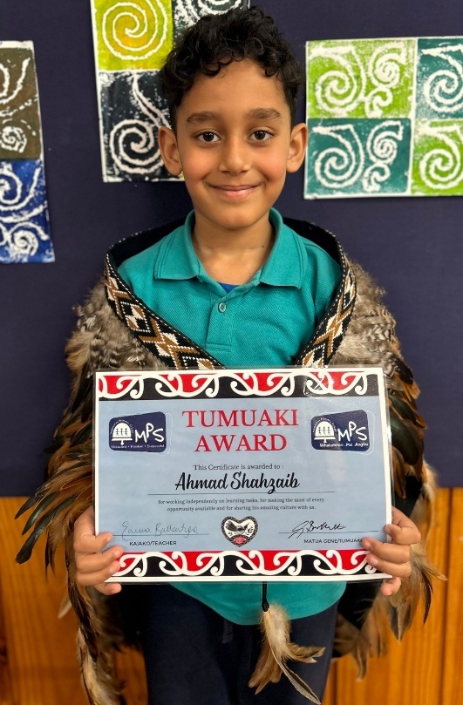Continuing to provide positive role modelling to their peers
* Running Te Tohu Whakapono Assemblies
* Meeting, greeting, and providing tours for school visitors
* Representing students’ ideas and opinions in school decision-making

The decision to appoint Te Tohu Whakapono Leaders, along with the associated rights and responsibilities, is made collectively by all Staff Members. Their leadership and dedication are crucial in fostering a positive and inclusive environment at Masterton Primary School.

#### Student acknowledgements

Every fortnight, we celebrate success with a school-wide assembly where parents can witness their children being acknowledged for their positive achievements. We recognize students for their commitment and engagement towards the school’s values, as well as their in-class and sports fair play behaviours. Additionally, we acknowledge each syndicate with Tumuaki (Principal) awards, and the recipients are then presented with their syndicate korowai. At Masterton Primary School, we value success and effort in all aspects of student life.

Leadership comes in many shapes and forms at Masterton Primary School, and we offer a wide range of student leadership opportunities. Our student leaders include librarians, road patrollers, student councillors, Te Whakapono students, sports leaders, and Eco Warriors. These dedicated students play a vital role in supporting our local curriculum by enabling various opportunities for their peers. We are tremendously grateful for their level of service and commitment to our school and community. Their contributions help create a vibrant and supportive environment for everyone.

*Whanaungatanga and Whakawhanaungatanga are Māori concepts that have similar meanings and are usually used interchangeably. These concepts don't translate to just one in English.*

**Whakawhanaungatanga**

At MPS, we are committed to fostering **whakawhanaungatanga**. Whakawhanaungatanga is a Māori concept that emphasises the importance of building and maintaining relationships and a sense of belonging within a community.

Between 8:40 am and 9:00 am, our students attend their **whānau groups** during Wā Whānau time, which means family time. During this time, students from Year 2 to Year 6 are mixed to create new class groupings across the school. Each of these classes is named after a different star in the Matariki constellation.

### Benefits of Vertical Classes in Wā Whānau

1. **Enhanced Social Skills**: Students interact with peers of different ages, promoting communication and social interaction skills.
2. **Peer Mentoring**: Older students have the opportunity to mentor and support younger students, fostering leadership and responsibility.
3. **Diverse Learning Experiences**: Mixed-age groups provide a range of perspectives and ideas, enriching the learning experience for all students.
4. **Stronger Sense of Community**: Vertical classes create a family-like environment, strengthening the sense of belonging and community within the school.
5. **Individualised Learning**: Teachers can tailor activities to a broader range of abilities, providing more personalized learning opportunities.

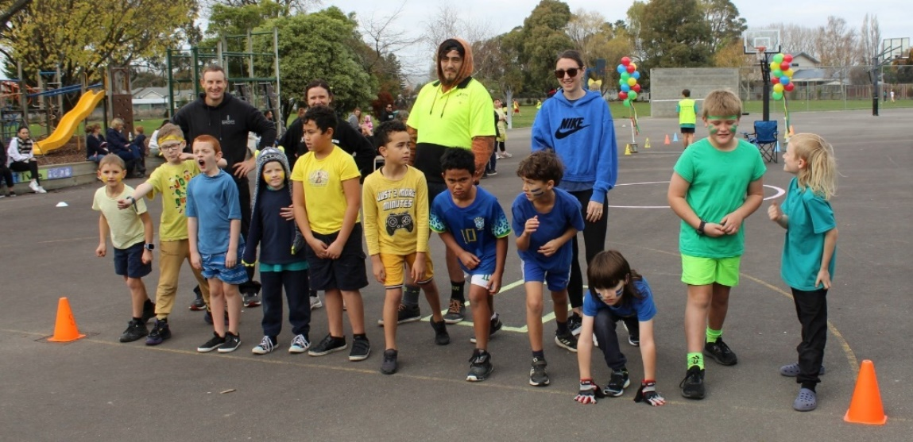**Whānau at the centre**

Whānau play a crucial role at Masterton Primary School. We rely on their presence at school-wide activities and learning discussions, as well as their participation in regular parent evenings. Their involvement is essential in fostering a supportive and engaged school community.

Hero LogoWhānau have just started using HERO as our student management system, some of the advantages are:

-Real-time visibility over their children's progress against the NZ and localised curriculums, including current learning goals and next steps.

-Whānau actively engage in rich learning conversations, through posting, commenting and reacting to their child’s digital portfolio.

-With fine-grain control over sending the right information to the right people, caregivers only receive information relevant to their family, boosting engagement.

**Coaches**

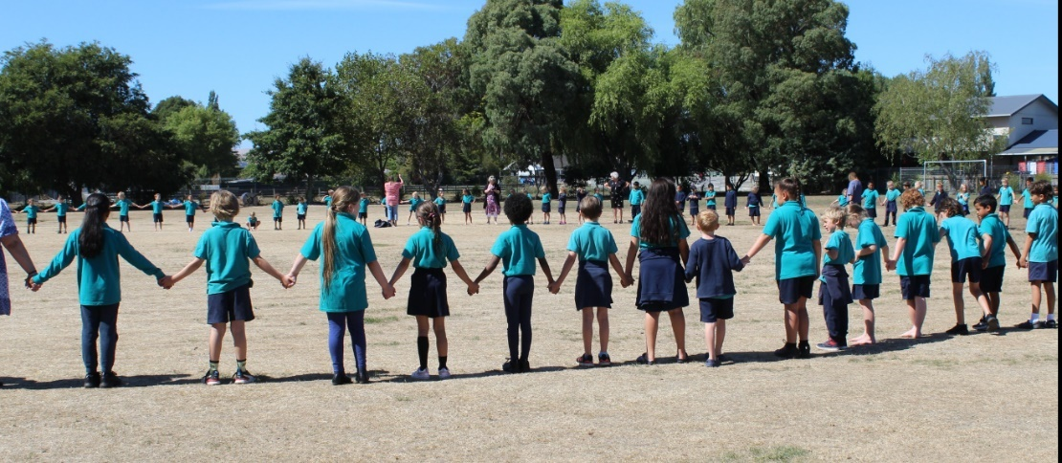At Masterton Primary School, our students have a passion for sports, and we are committed to providing them with opportunities to thrive. We are fortunate to have dedicated coaches and managers from within our community, including many talented parents who are accomplished sportspeople in their own right. Leveraging these talents ensures that our students receive the best possible guidance and support, fostering their growth and success in various sports activities.

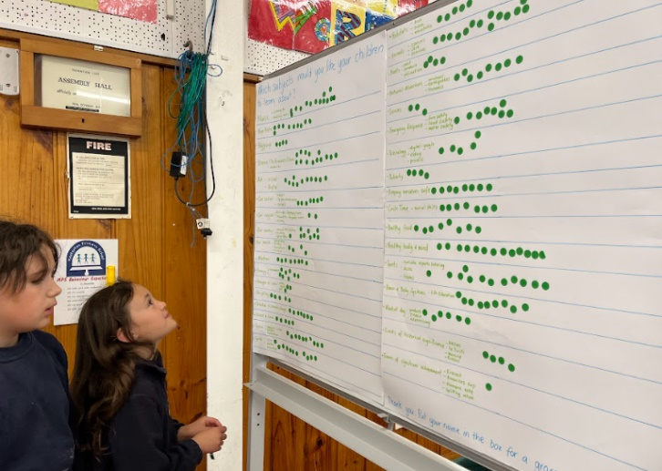**Community consultation**

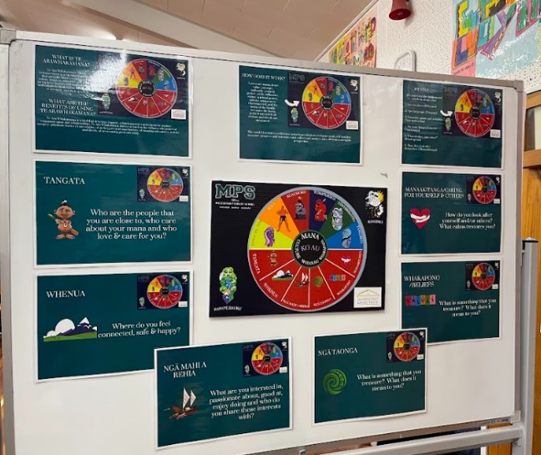In 2023, we conducted consultations on the Health & PE curriculum, Te Reo Māori (Te Arawhakamana), as well as Kapa Haka and Pasifika themes. We deeply value the input of our parents in shaping our strategic plan. A key area identified for development through these consultations was emotional intelligence within our community. In 2024, we consulted with our whānau about the phones in school policy. As a result of this feedback, we will be hosting a community evening with Rob Cope focused on cyber safety. We have also implemented the SchoolDocs governance platform to create a clear line of sight for our policies and procedures. An important part of this process is regular community consultation conducted throughout the year.

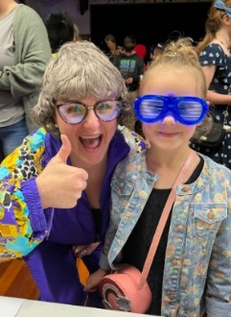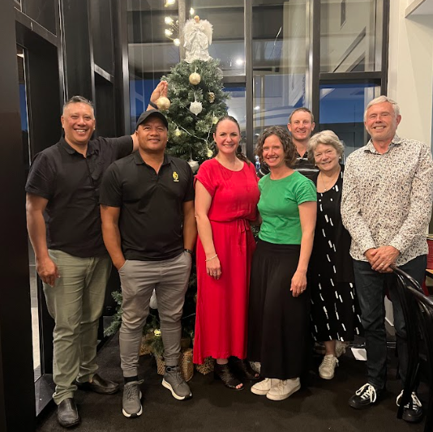**Board of Trustees**

We are fortunate to have an exceptional Board of Trustees led by Jo-Anne Twiggins. Jo-Anne leads an inspiring group of parents who possess a deep understanding of the needs of our school and community. The primary purpose of the Board of Trustees is to provide governance and strategic direction, ensuring the school achieves its educational objectives and maintains a high standard of learning. Their support is invaluable in helping the school achieve its annual goals and fostering a positive educational environment.

Using SchoolDocs at Masterton Primary School streamlines our governance and decision-making processes by providing a comprehensive and accessible repository of policies and procedures. This resource eliminates the need to create documents from scratch, allowing staff to quickly locate and review necessary information online. This efficiency not only reduces costs but also enhances the effectiveness of our policies and procedures, giving principals, senior management, and boards more time to concentrate on teaching and learning.

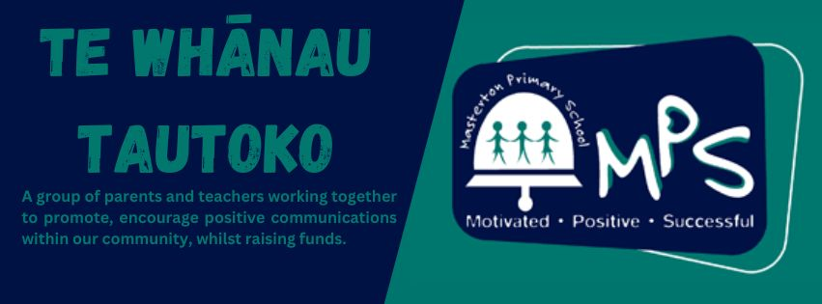Regular, small reviews through SchoolDocs keep the board current and engaged with policy updates and new content in manageable increments, preventing the overwhelming task of large, infrequent reviews



### **Te Whānau Tautoko**

We have an incredible fundraising team called Te Whānau Tautoko (TWT), dedicated to supporting our schools and community’s. Led by the wonderful Vic Nation, who brings a wealth of knowledge and experience, TWT is instrumental in raising funds for various projects. Their most recent mission is to build a bike track by the end of the year. Vic's leadership, combined with her fantastic team of supporters, ensures that TWT continues to make a significant impact on our school and its environment.

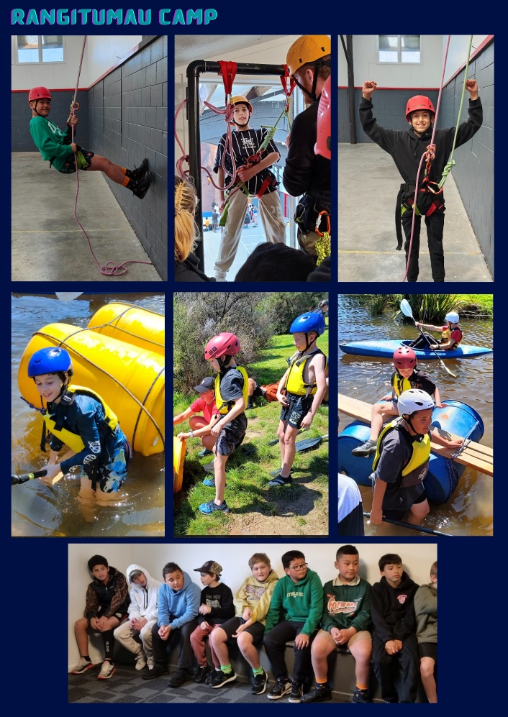

**Active students active minds**

### Sport at MPS: Enhancing Physical and Social Development

At MPS, our students love sports. Engaging in sports is a fantastic way to develop social interactions and stay physically active. Participating in sports offers numerous benefits, including:

1. **Physical Fitness**:
   * Regular physical activity helps improve cardiovascular health, strengthen muscles, and enhance overall physical well-being.
2. **Teamwork and Cooperation**:
   * Sports teach students the value of teamwork and cooperation, as they work together towards common goals.
3. 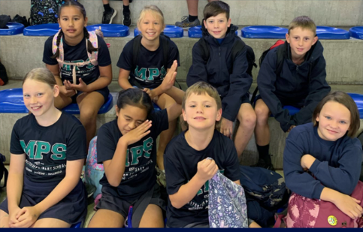**Discipline and Time Management**:
   * Balancing sports and academics helps students develop discipline and effective time management skills.
4. **Stress Relief**:
   * Physical activity is a great way to relieve stress and improve mental health, contributing to a balanced lifestyle.
5. **Self-esteem and Confidence**:
   * Success in sports can boost self-esteem and confidence, encouraging students to take on new challenges.

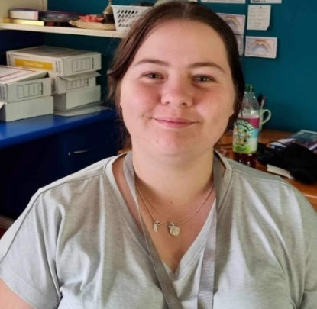Sophia Breen, our wonderful sports coordinator, ensures that our children have a range of fantastic opportunities to succeed in sports. Our sport leaders are out each day running activities, and we have a specific staff member who oversees lunchtime sports activities.

In 2023, our parent group, Te Whānau Tautoko, generously purchased new sports uniforms. This has made our student volunteers feel extra special when playing away, fostering a sense of pride and unity.

**Education outside the classroom**

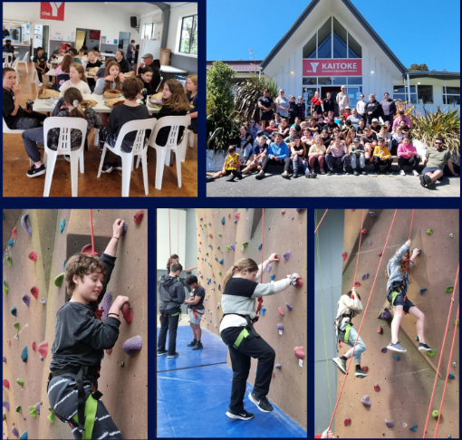We highly value Education Outside the Classroom (EOTC) experiences for our students at Masterton Primary School. All classes are encouraged to participate in various EOTC activities, such as attending school camps, visiting local museums, and engaging in inter-school sports.

Our Board of Trustees supports these initiatives by subsidising the annual Riversdale Beach camp for our Year 5 and 6 senior classes. This camp aims to develop stronger relationships within the class, fostering teamwork and camaraderie.

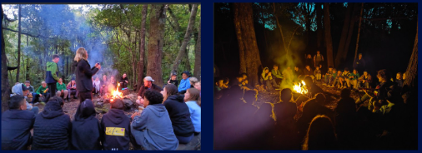Additionally, we now have a school van that transports our students to events, significantly breaking down barriers and providing more opportunities for our students to engage in enriching experiences outside the classroom.

**STEM**

We offer a wide range of experiences focused on STEM initiatives, arts, and discovery learning to provide unique opportunities for our students to succeed. Some of the key programs and activities include:

* Field-based STEM projects
* House of Science kits
* Aqua Bots
* Lego Spike
* Arts rotation
* Minecraft Club
* Discovery learning
* Matariki Space Dome

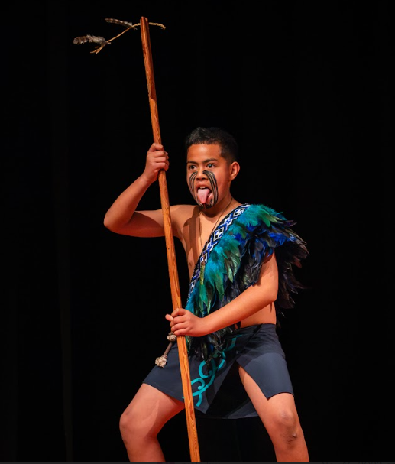These diverse experiences are designed to engage our students in hands-on, innovative learning, fostering creativity, critical thinking, and a passion for exploration. Through these programs, our children are empowered to excel in various fields and develop a lifelong love of learning.

**Giving effect to Te Tiri o Waitangi**

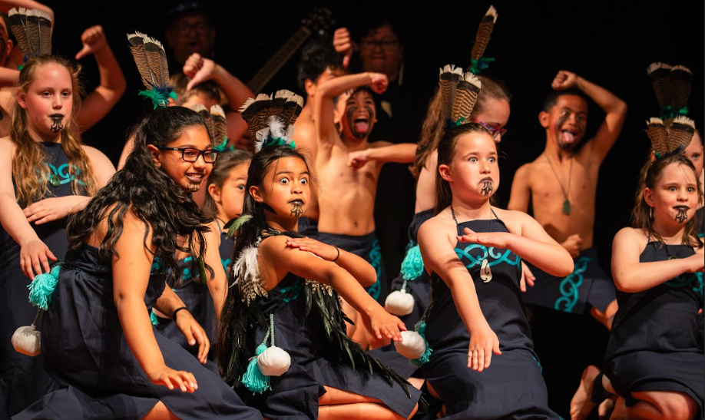At MPS, we recognize the importance of Te Tiriti o Waitangi and the unique place tangata whenua hold in our school. We incorporate Te Reo Māori concepts such as karakia, whakatauki, kapa haka, and Te Reo Māori lessons, enriching both our school and community. Our annual participation in the regional kapa haka festival showcases the talents at MPS.

MPS is part of the Whakaoriori Kāhui Ako, with two staff members actively involved in the Wairarapatanga workstream. We consult with Te Reo facilitators like Nathan Riki and Janelle Riki-Waaka, who support us in assessing the cultural capabilities of our organization and identifying strengths and opportunities for development.

**Why Developing Cultural Competencies is Important to Us**

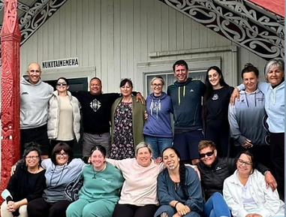Developing cultural competencies is essential for our organization because it fosters a deeper understanding and respect for the diverse backgrounds within our community. This commitment enhances the work we do by creating an inclusive environment where all students and staff feel valued and understood. It also strengthens our educational practices, ensuring that we honour the cultural heritage and contributions of tangata whenua, which in turn enriches the educational experience for everyone at MPS.



